1.EQUI JOIN:
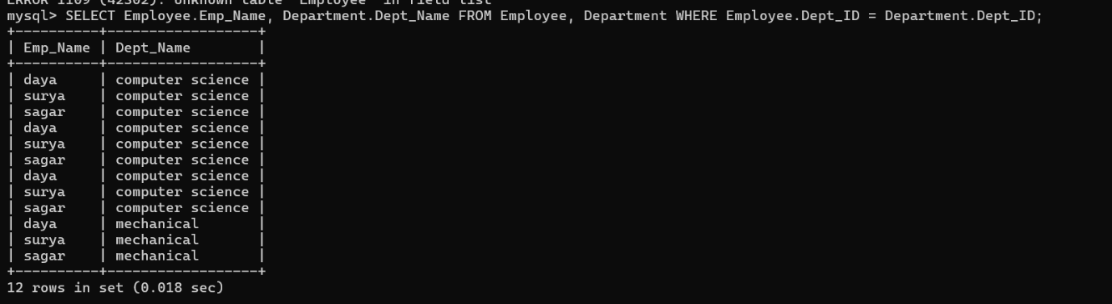
2.INNER JOIN:
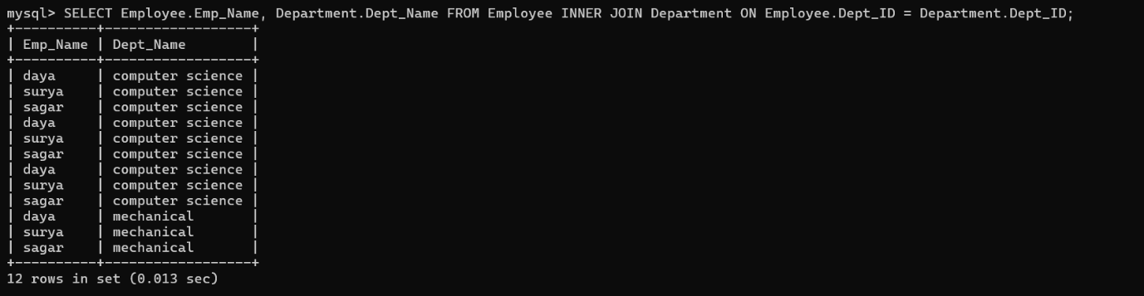
3. OUTER JOIN (LEFT AND RIGHT):
